|  |  |  |  |
| --- | --- | --- | --- |
|  | Myo | Ninapro DB5 | CAPG |
| Available Subjects | 19 | 10 | 23 |
| EMG - Channel | 8 | 16 | 2x8 |
| Sampling Rate (Hz) | 200 | 200 | 1000 |
| Electrode Type | Dry | Dry | Gel-Based |
| Measurement Tool | 1 x Myo Armband | 2 x Myo Armband | HD-sEMG |
| Nubmer of movements | 7 | 53 | 22 |

**Dry electrodes** are **less accurate** and **robust** to **motion artifact than gel-based ones.**

The **recommended frequency** range of sEMG signals is **5-500Hz. At least 1000Hz is required. 🡪 Information loss**

**MYO**

**NinaPro DB5**

The dataset is divided into three exercise sets.

1. Basic movements of the fingers
2. Isometric, isotonic hand configurations and basic wrist movements
3. Grasping and functional movements

Figure 1: Basic movements of the fingers

Figure 2: Isometric and isotonic hand configuration

Figure 3: Basic Wrist movement

Figure 4: Grasping and functional movements

**CAPG**

The set of gestures of the CAPG is a **subset of the NinaPro database.**

Figure : The HD-sEMG electrode array

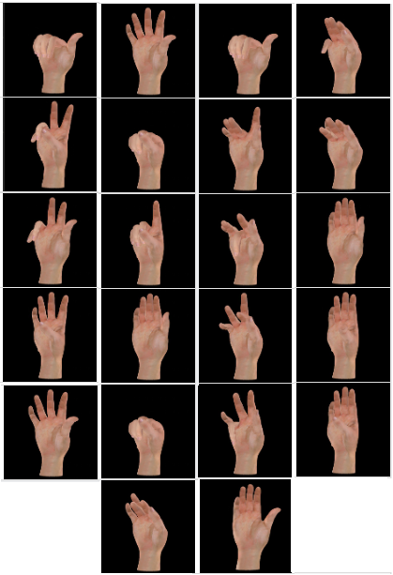

Figure : CAPG Movements